COS 420
Team G
Deliverable 3
10/31

The user class is the public interface that accesses the rest of the domain model. The user has a username and password, which are used to login, logout, create account, and delete account. It does this through the budget class, which stores income, total expenditure, and a list of each category. The user can create a visualization of their budget or add a category. The category stores the maximum spending, amount spent, period, any alerts, and a list of each transaction. For a category, you can createCategory or addTransactions. Each transaction is a single spending instance that stores the amount spent, date, memo, and transaction ID. For a transaction, you can createTransaction or editTransaction.

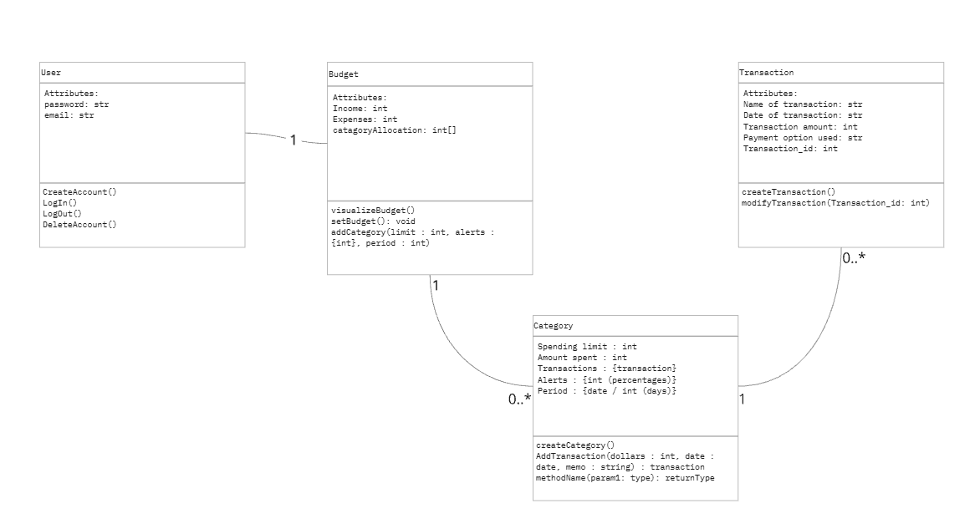
https://miro.com/app/board/uXjVLMUAsiM=/
Object List
- User
  - Email : string
  - Password : hash
  - Login() : Bool
  - Logout() : None
  - CreateAccount() : User
  - DeleteAccount() : None

- Budget:
  - Income: int
  - Expenses: int
  - categoryAllocation: int[]
- setBudget()
- visualizeBudget()
- addCategory(limit: int, alerts: [int], period: int)

- Category
  - Spending limit: int
  - Amount spent: int
  - Transactions : {transaction}
  - Alerts : {int (percentages)}
  - Period : {date / int (days)}
  - createCategory()
  - AddTransaction(dollars : int, date : date, memo : string) : transaction
  - methodName(param1: type): returnType

- Transaction
  - Name of transaction: str
  - Date of transaction: str
  - Transaction amount: int
  - Payment option used: str
  - Transaction_id: int
  - createTransaction()
  - modifyTransaction(Transaction_id: int)

